12 ATAR PSYCHOLOGY 2016

TEST ONE

Name: ____________________ Teacher: ___________________ Mark: /44

Percentage: %

Section One: Research methods (21 marks)

Question 1 (12 marks)

Dr Scott wanted to test whether a vitamin supplement helped to improve students’ grades. To test her idea, she told her class she was giving them all a supplement that would make them smarter. She told them they all had to participate. Dr Scott then divided the class into two equal groups. Group A received the vitamin supplement and Group B received an inactive substance (sugar pill).
Over the two week trial, Dr Scott spent a lot of time with the students gathering data. She was excited to find that the results showed that all students’ grades had improved. She concluded that the vitamin supplement had worked.

(a) Explain what Dr Scott should do after the experiment has ended to make sure the research has
been conducted ethically. (1 mark)

_____________________________________________________________________________________

_____________________________________________________________________________________

(b) Outline how Dr Scott may have affected the results of the experiment. (1 mark)

_____________________________________________________________________________________

_____________________________________________________________________________________

_____________________________________________________________________________________

_____________________________________________________________________________________

(c) Explain the difference between the terms ‘population’ and ‘sample’ in psychological research.
(2 marks)

_____________________________________________________________________________________

_____________________________________________________________________________________

_____________________________________________________________________________________

_____________________________________________________________________________________

_____________________________________________________________________________________

_____________________________________________________________________________________
(d) (i) Outline three (3) ethical issues associated with this research. (3 marks)

______________________________________________________________________________

______________________________________________________________________________

______________________________________________________________________________

______________________________________________________________________________

______________________________________________________________________________

______________________________________________________________________________

(ii) Identify two (2) sources of error in the design of this experiment. (2 marks)

______________________________________________________________________________

______________________________________________________________________________

______________________________________________________________________________

______________________________________________________________________________

______________________________________________________________________________

______________________________________________________________________________

(e) State whether the method of the research used ‘independent measures’ or ‘repeated measures’
and explain the reason for your response. (2 marks)

_____________________________________________________________________________________

_____________________________________________________________________________________

_____________________________________________________________________________________

_____________________________________________________________________________________

_____________________________________________________________________________________

_____________________________________________________________________________________

(f) Identify the sampling method that Dr Scott used in her research. (1 mark)

_____________________________________________________________________________________

Question 2 (6 marks)

A psychologist wanted to investigate the relationship between temperature and performance on a test of divided attention. The psychologist required a sample of 60 adults to participate in the study. Each participant would complete a divided attention task under two conditions: firstly in a room where the temperature was 16°C; and secondly in a room where the temperature was 24°C.

(a) Identify whether this is an experimental or non-experimental study and give a reason for your
answer. (2 marks)

_____________________________________________________________________________________

_____________________________________________________________________________________

_____________________________________________________________________________________

_____________________________________________________________________________________

_____________________________________________________________________________________

(b) Identify

(i) the independent variable for the study. (1 mark)

______________________________________________________________________________

(ii) the dependent variable for the study. (1 mark)

______________________________________________________________________________

The results of the study are shown in the table below. Higher scores indicate better performance on the divided attention task.
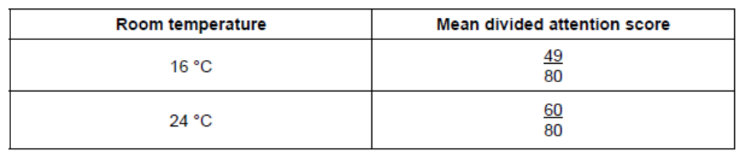

A statistical test on the difference between the two mean scores found p < 0.05.

(c) Explain the meaning of ‘p < 0.05’. (2 marks)

_____________________________________________________________________________________

_____________________________________________________________________________________

_____________________________________________________________________________________

_____________________________________________________________________________________

_____________________________________________________________________________________
Question 3 (3 marks)
A psychologist was interested in the relationship between how strongly a person identifies with a particular ethnic group (ethnic identity) and their resilience to stress. The psychologist collected questionnaire measures of ethnic identity and resilience from 300 volunteer adults.

(a) State a hypothesis that the psychologist could develop for this study. (1 mark)

_____________________________________________________________________________________

_____________________________________________________________________________________

_____________________________________________________________________________________

_____________________________________________________________________________________

_____________________________________________________________________________________

_____________________________________________________________________________________

The results of the study are shown in the scattergram below.
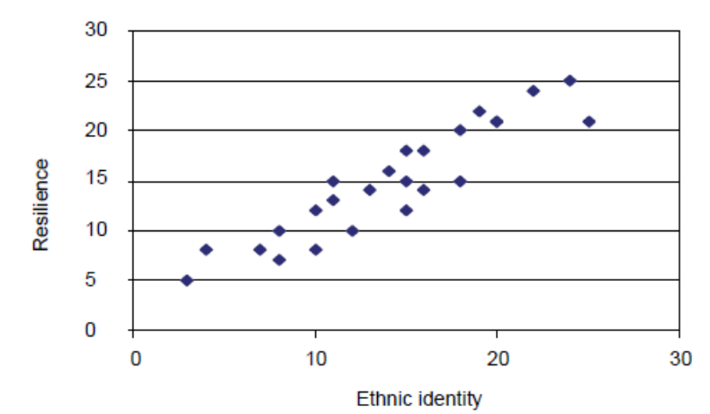

(a) (i) Identify the nature of the relationship between the two variables shown in the scattergram.
(1 mark)

_______________________________________________________________________________

(ii) Do the results shown in the scattergram support the hypothesis stated in Question 1(a)?
(1 mark)

_______________________________________________________________________________

Section Two: Short answer (23 marks)

Question 4 (5 marks)

(a) After falling off his bike on the way to school during the first week of term, Matt spent two weeks in
hospital. Matt returned to school in the 4th week of term and is having difficulty recognising his
school friends. State the lobe of the brain that he has most likely damaged. (1 mark)

_____________________________________________________________________________________

(b) Tom is an excellent musician. Which hemisphere of the brain is likely to be more dominant when he
plays the guitar? (1 mark)

_____________________________________________________________________________________

(c) The primary sensory cortex and primary motor cortex lie next to each area on the cerebrum. For
each area, state the lobe of the brain that it resides in. (2 marks)

_____________________________________________________________________________________

_____________________________________________________________________________________

_____________________________________________________________________________________

(d) Identify a function of the myelin sheath. (1 mark)

_____________________________________________________________________________________

_____________________________________________________________________________________

_____________________________________________________________________________________

Question 5 (10 marks)

(a) List two (2) effects of each of the following neurotransmitters.

(i) Noradrenaline (2 marks)

_____________________________________________________________________________

_____________________________________________________________________________

(i) Endorphins (2 marks)

_____________________________________________________________________________

_____________________________________________________________________________

(b) While she was out walking, Maddy was startled by a dog suddenly barking at her from behind a
fence, causing her heart to race and her blood pressure to increase. As she continued on her walk,
Maddy’s blood pressure and heart rate returned to normal levels. Identify the type of nervous
system that allowed her blood pressure and heart rate to return to normal levels. (1 mark)

_____________________________________________________________________________________

(c) The peripheral nervous system can be subdivided into two nervous systems that have quite distinct
features. Identify these two nervous systems. (2 marks)

_____________________________________________________________________________________

_____________________________________________________________________________________

(d) Contrast between a pre-synaptic neuron and a post-synaptic neuron. (2 marks)

_____________________________________________________________________________________

_____________________________________________________________________________________

_____________________________________________________________________________________

_____________________________________________________________________________________

(e) Damage to Broca’s area is known as Broca’s aphasia. Describe one main difficulty someone who
suffers from Broca’s aphasia would have. (1 mark)

_____________________________________________________________________________________

_____________________________________________________________________________________

Question 6 (8 marks)

(a) Frontal lobotomies were used in the early 20th century to ‘cure’ people of schizophrenia. This
involved removing a part of the patient’s frontal lobe. Give two possible side effects that could
result from this surgery. (2 marks)

_____________________________________________________________________________________

_____________________________________________________________________________________

_____________________________________________________________________________________

(b) State the name of the primary cortex that is located at the rear of the frontal lobe. (1 mark)

_____________________________________________________________________________________

(c) Label the four lobes of the brain on the diagram below. (4 marks)

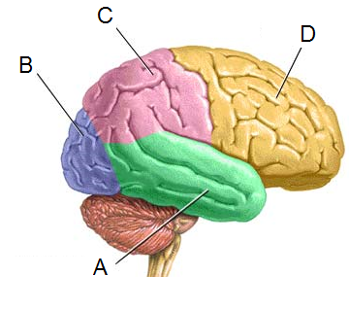

A: _____________________________________________

B: _____________________________________________

C: _____________________________________________

D: _____________________________________________

(d) Tabitha was cleaning out her gutters on the weekend and was on a high ladder. She slipped while
reaching for some leaves, fell off the ladder and hit her head quite hard on the concrete below.
Once Tabitha regained consciousness she experienced difficulty moving her right hand. Identify the
lobe of the brain most likely affected in this case. (1 mark)

_____________________________________________________________________________________

